**Lab 2 –Software Project Management**

**Gianna Galard**

**CSC430**

**Prof. Zhanyang Zhang**

**Lab Description:**

This lab aims to understand the importance of software project management and practice the skills to (1) Identify and develop project scope (2) plan and manage the project schedule. Learn how to use a project management system tool, such as Microsoft Office Project, to develop and manage the project schedule.

**Part A – Project Scope Development**

This Café Management System is designed to help local Cafés with their staff management, current dishes on the menu, inventory management, and provides the owner/management the popularity of each plate with the customer statistics with the help of a simple GUI.

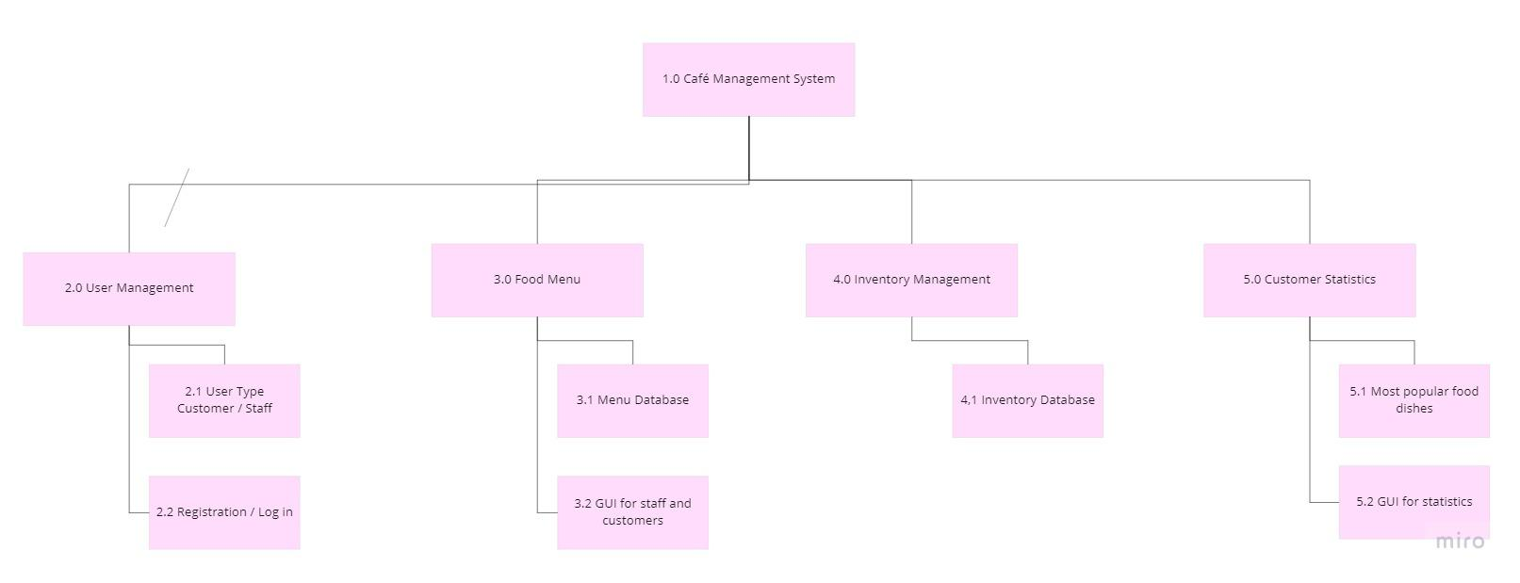

**Part B – Project Plan and Schedule Management**

| **Activity** | **Duration** | **Dependencies** |
| --- | --- | --- |
| 2.1 | 6 |  |
| 2.2 | 12 | 2.1(M0) |

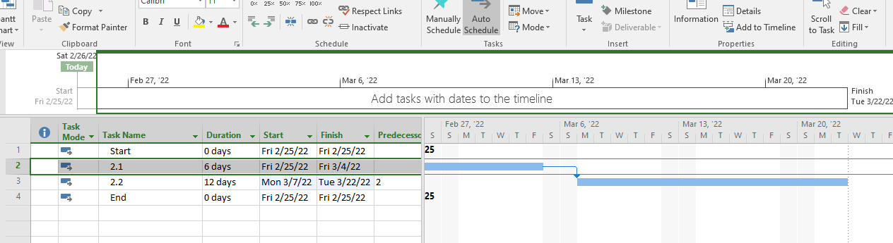

* How many paths in the project activity network ?
  + **1**
* Which path is the critical path ?
  + **2.1 -> 2.2**
* What is the slack time of each path ?
  + 
  + **18 Day Slack Time**

**Rolling Dice !!!**

**T1**

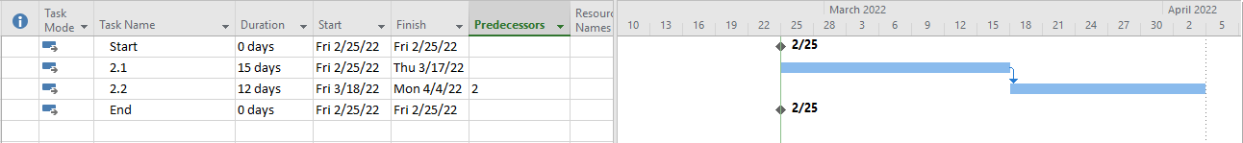

Rolled a 5, duration changed to 15 days

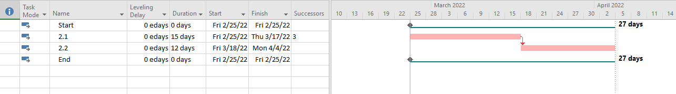

Slack Time changed to 27 days

**T2**

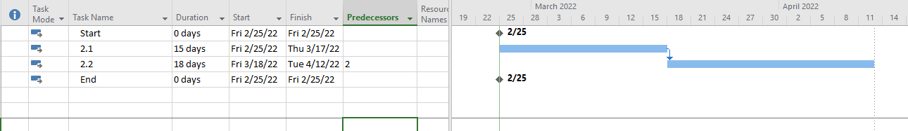

Rolled a 6, duration changed to 18 days

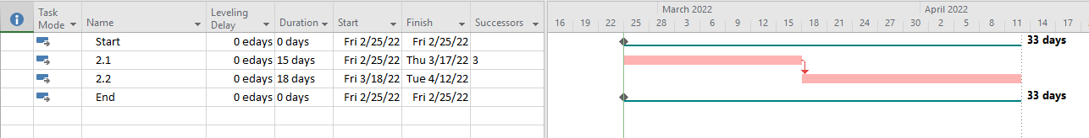

Slack Time changed to 33 days